**B.Nikhil**

**192111054**

**OBJECT ORIENTED ANALYSIS AND DESIGN FOR SOFTWARE DESIGN(CSA1176)**

LAB DAY-02

**1.Conference Management System**

**Use case Diagram**

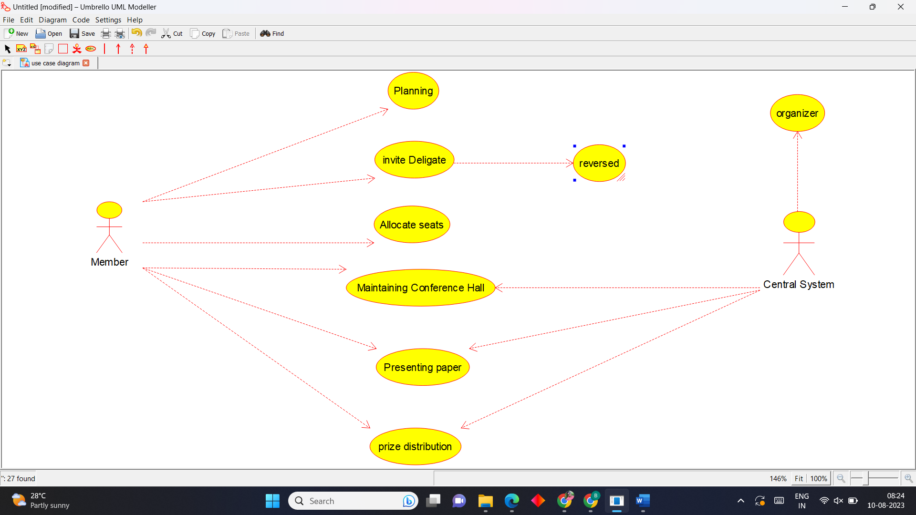

**Class Diagram**

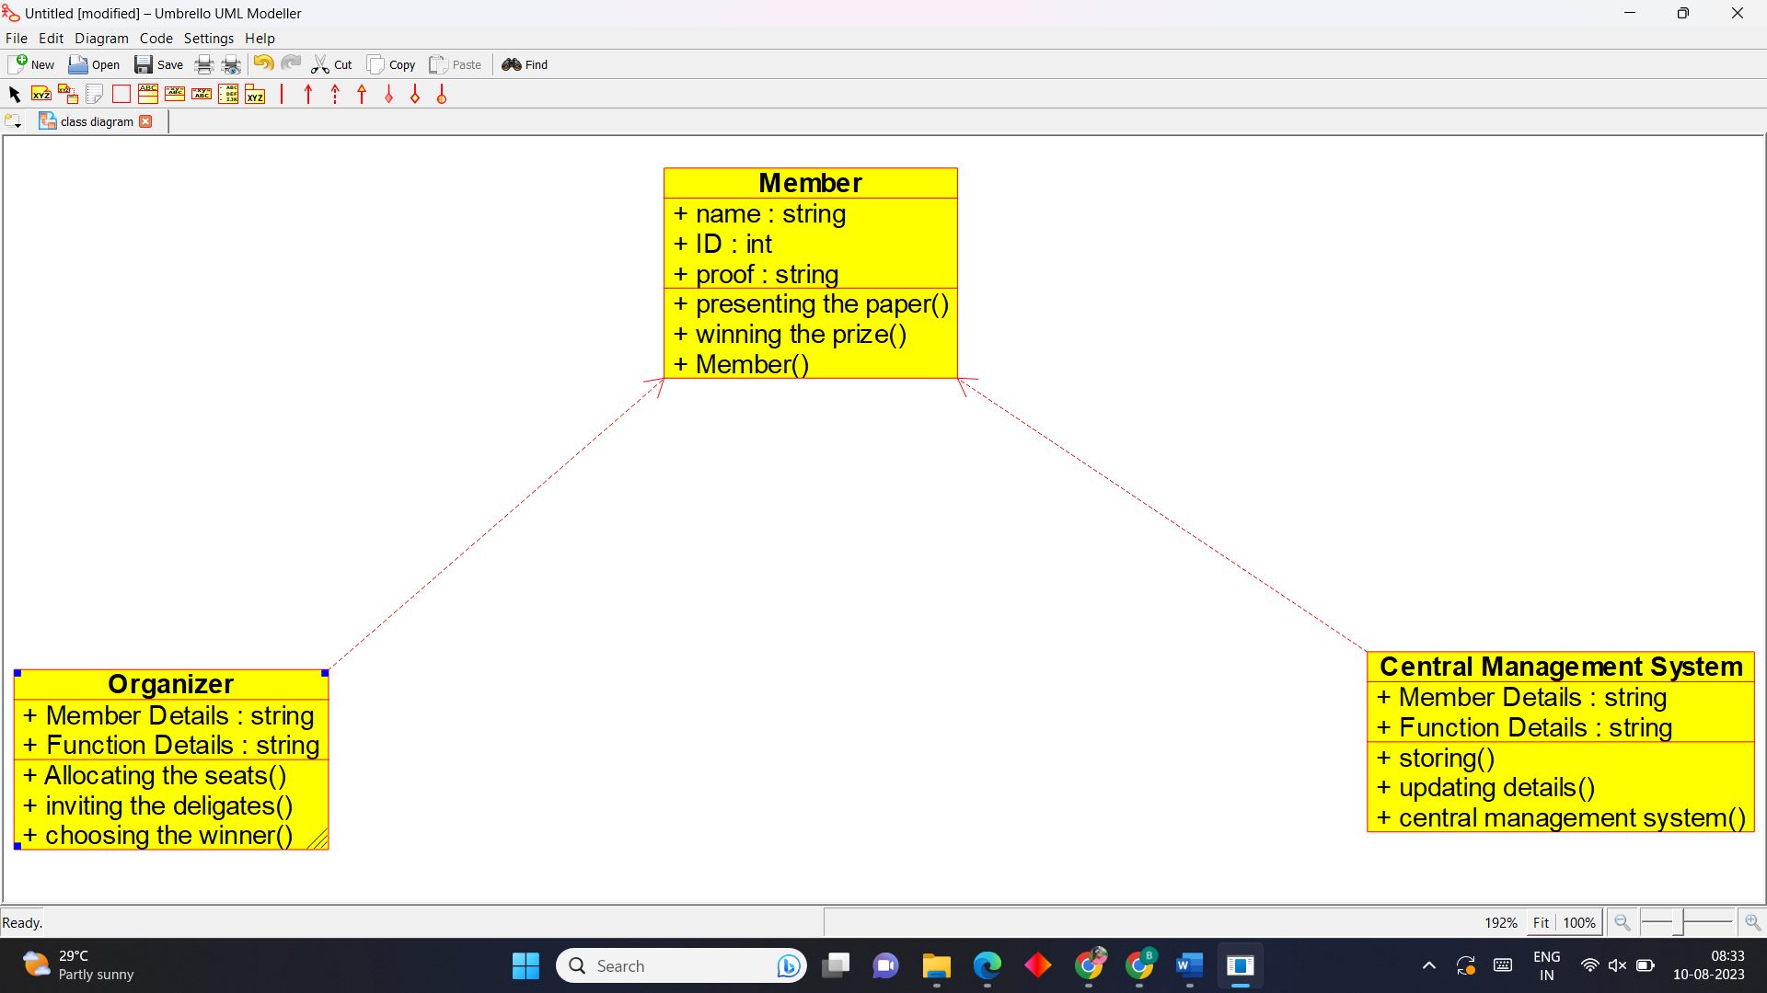

**Activity Diagram**

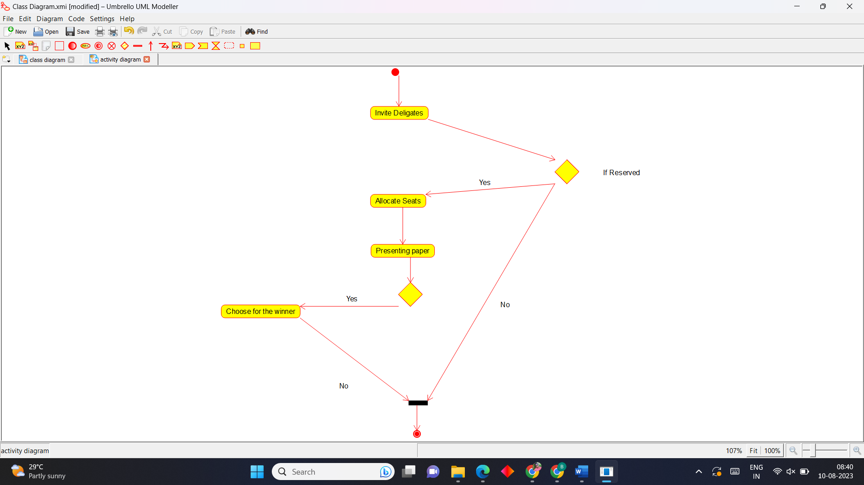

**Sequence Diagram**

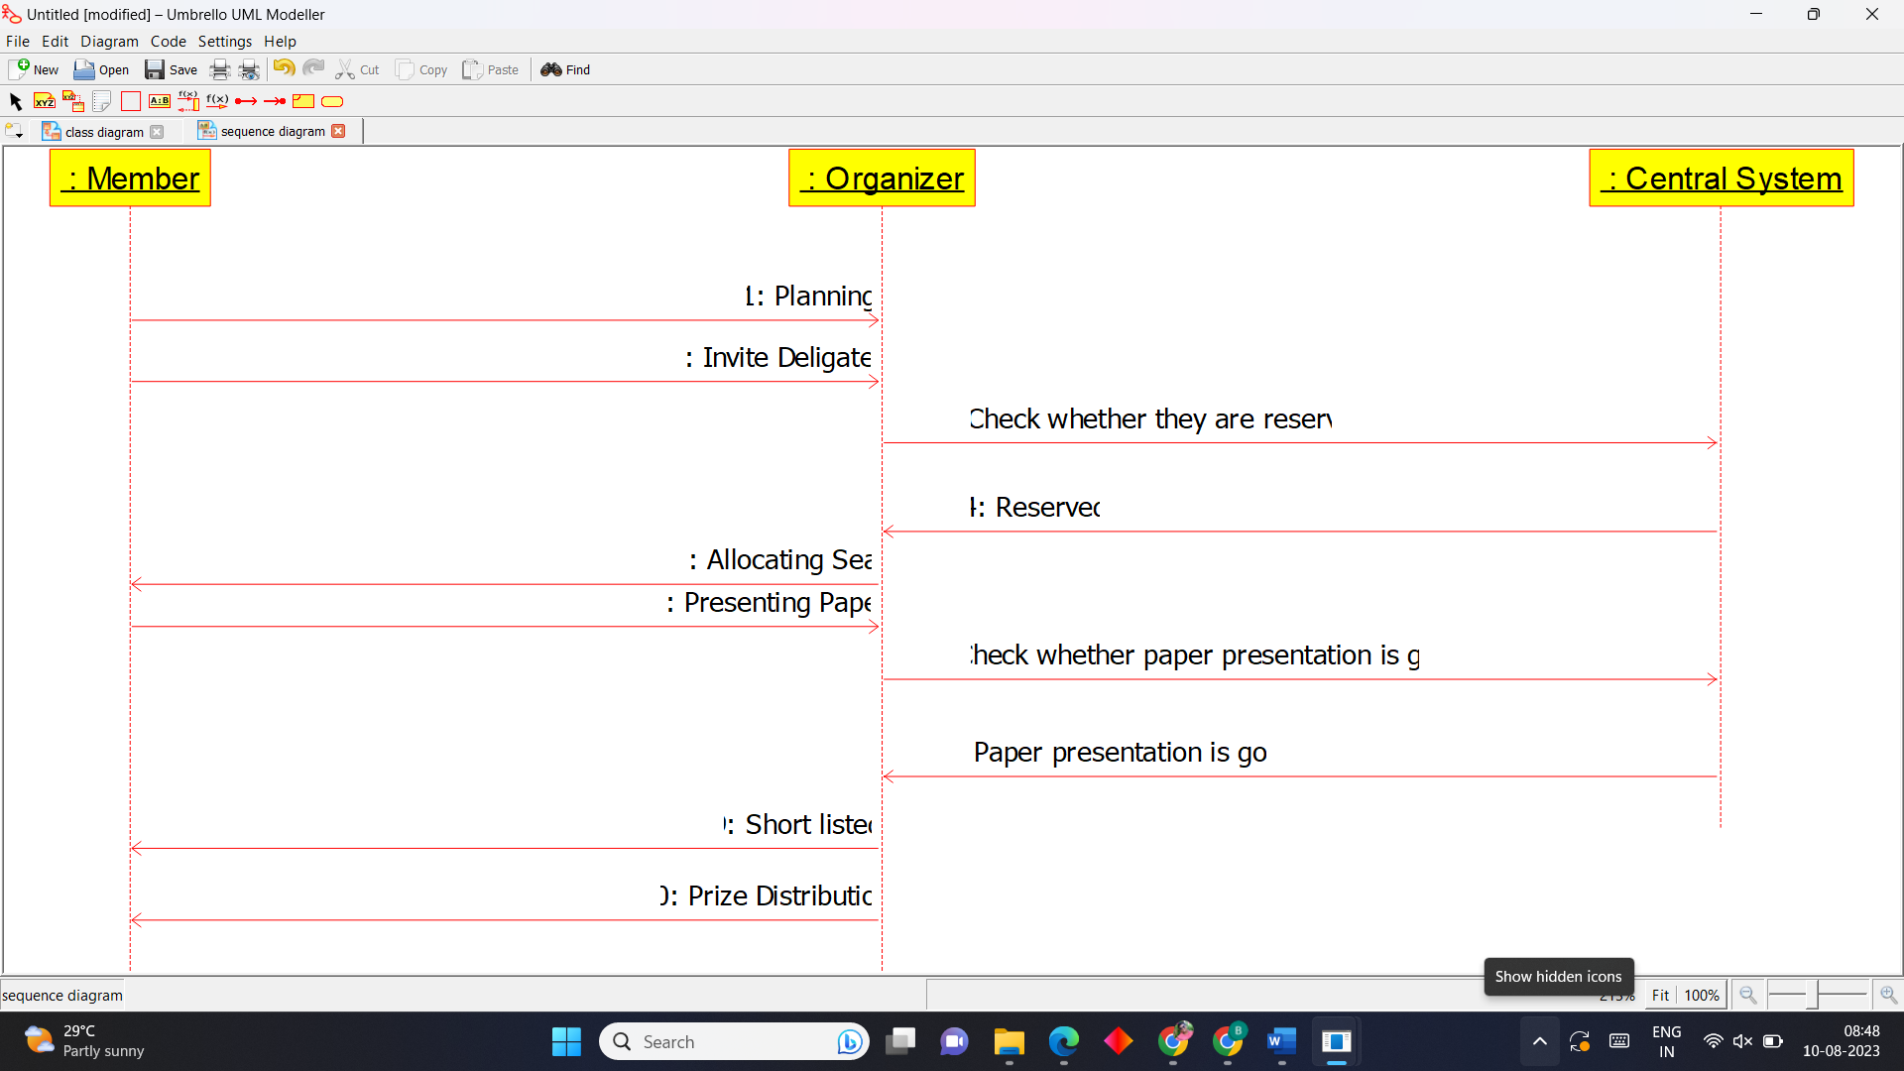

**2.Foreign Trading System**

**Use Case Diagram**

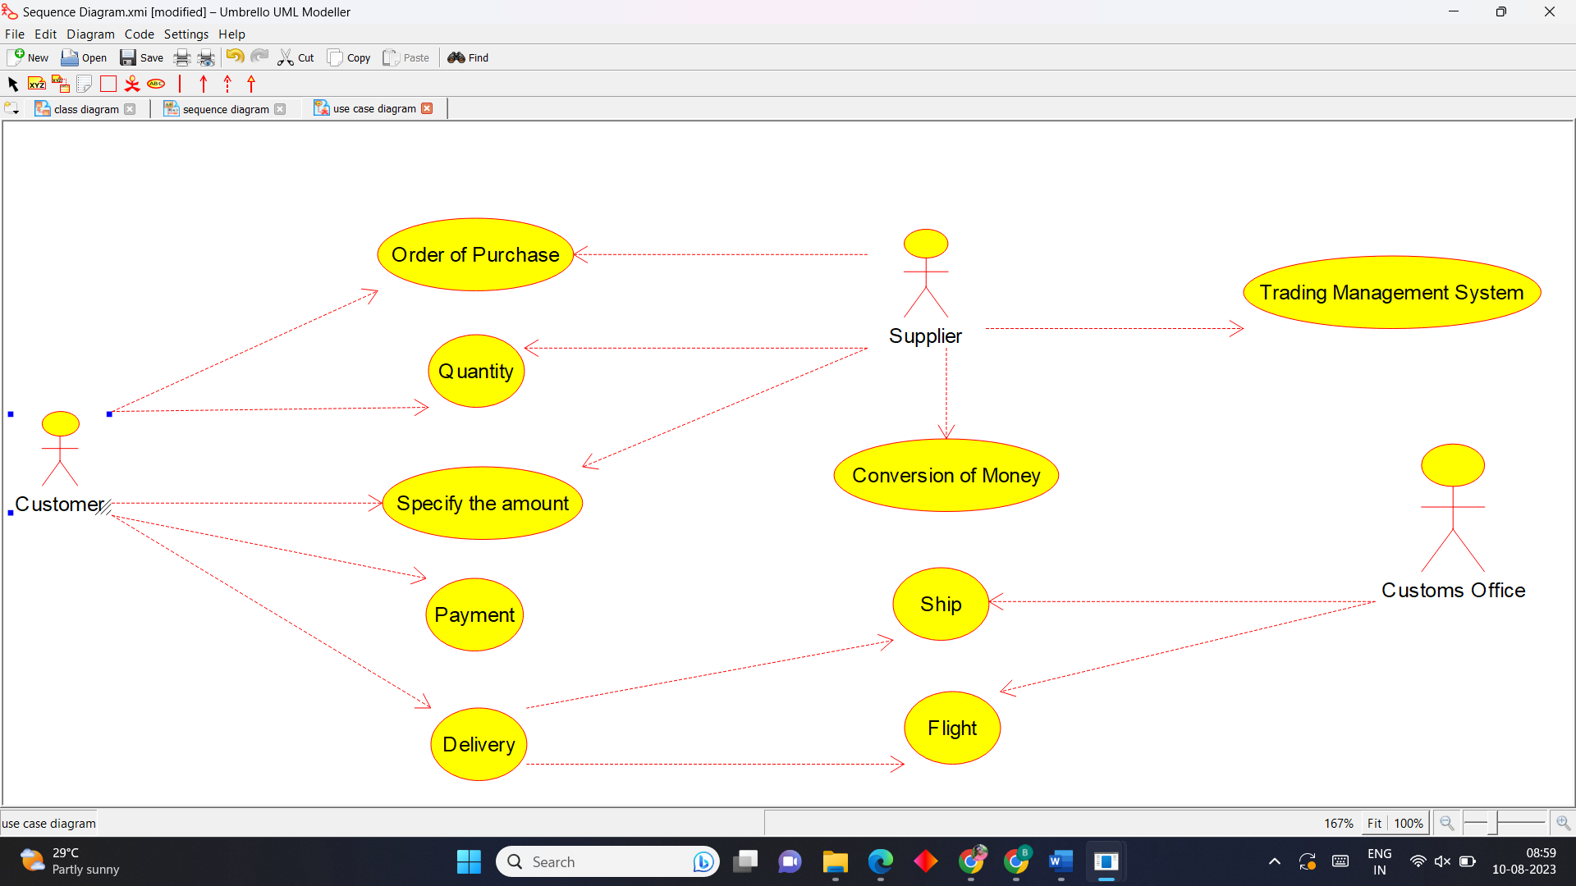

**Class Diagram**

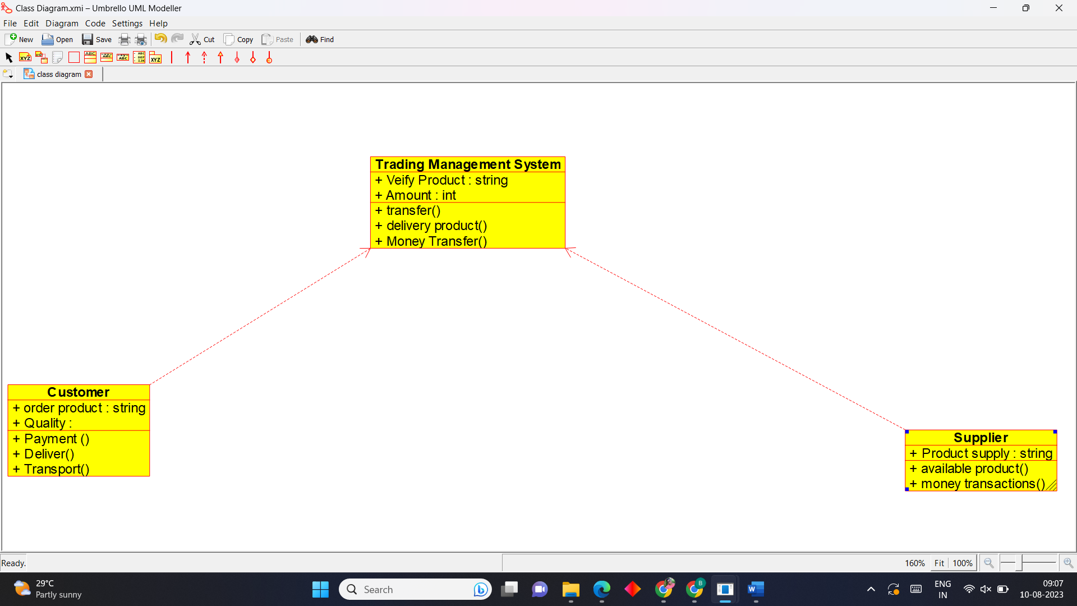

**Activity Diagram**

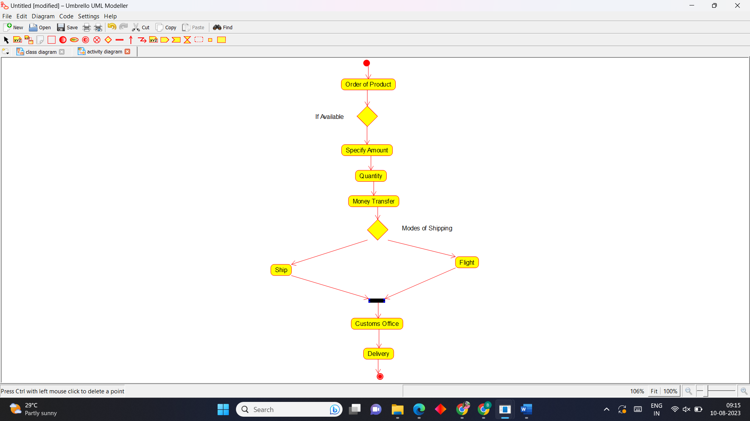

**Sequence Diagram**

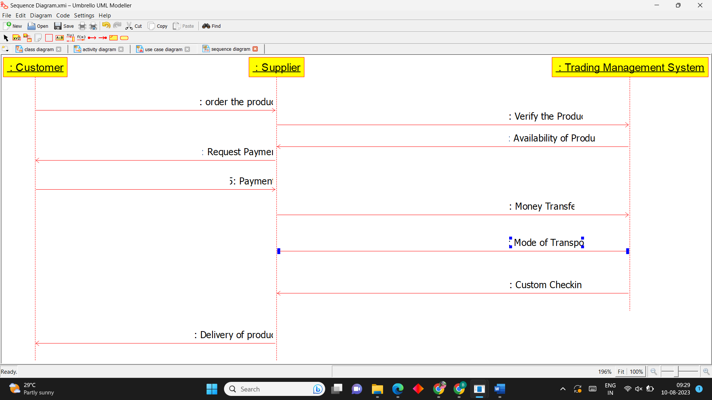

**3.BPO Management System**

**Use Case Diagram**

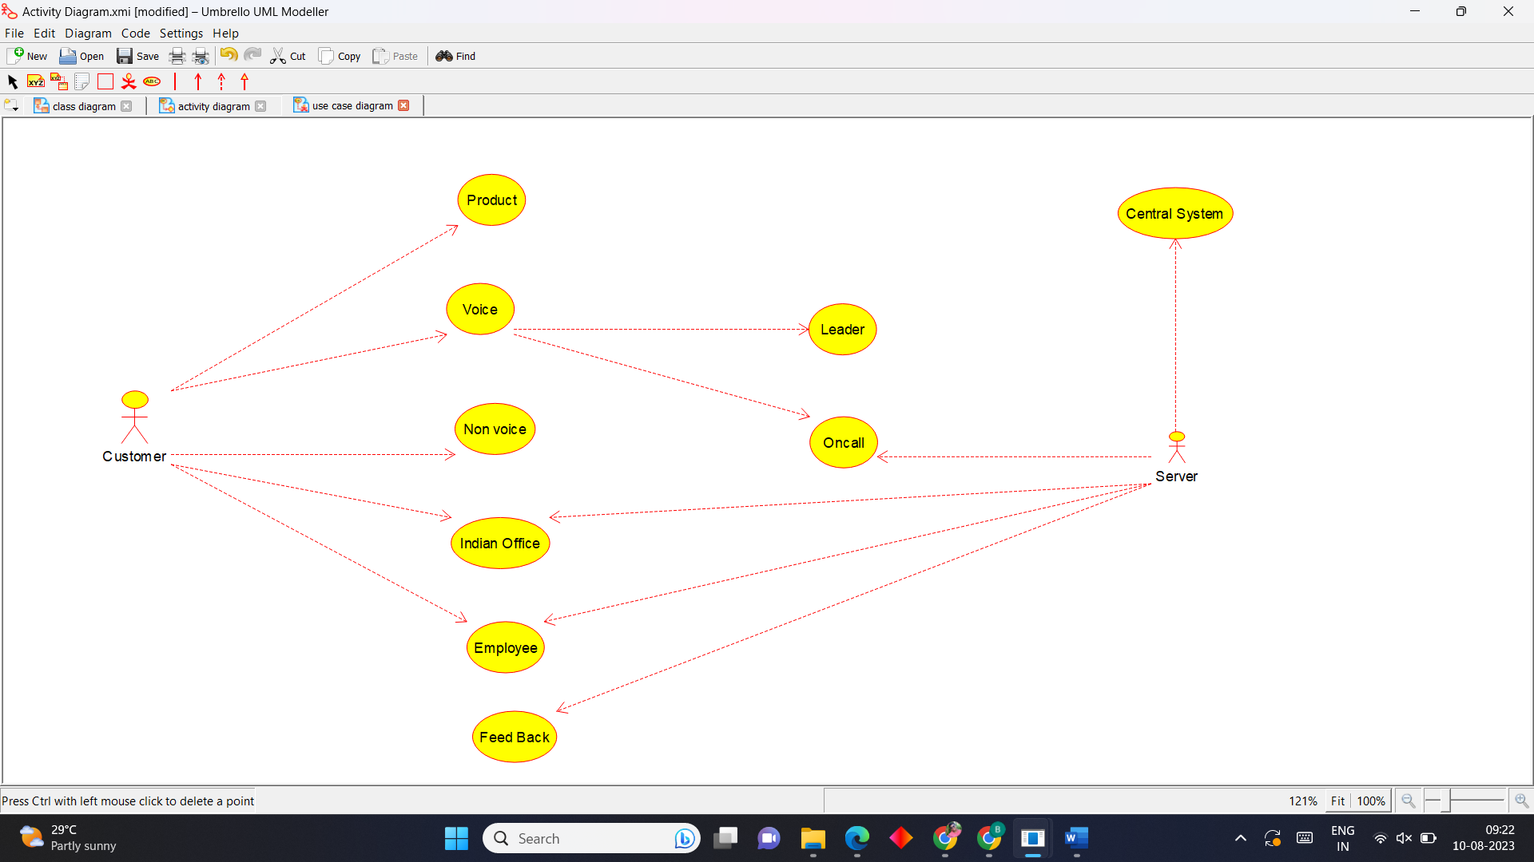

**Activity Diagram**

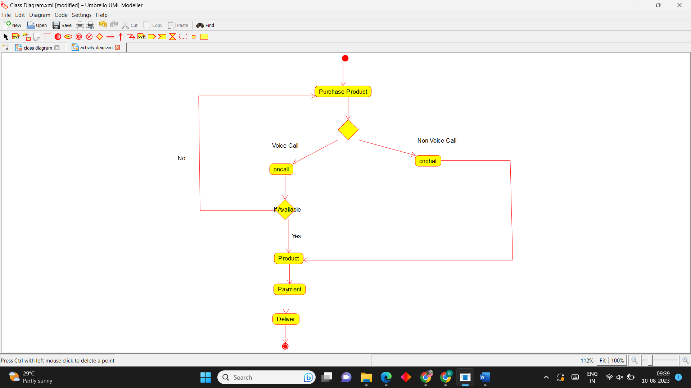

**Sequence Diagram**

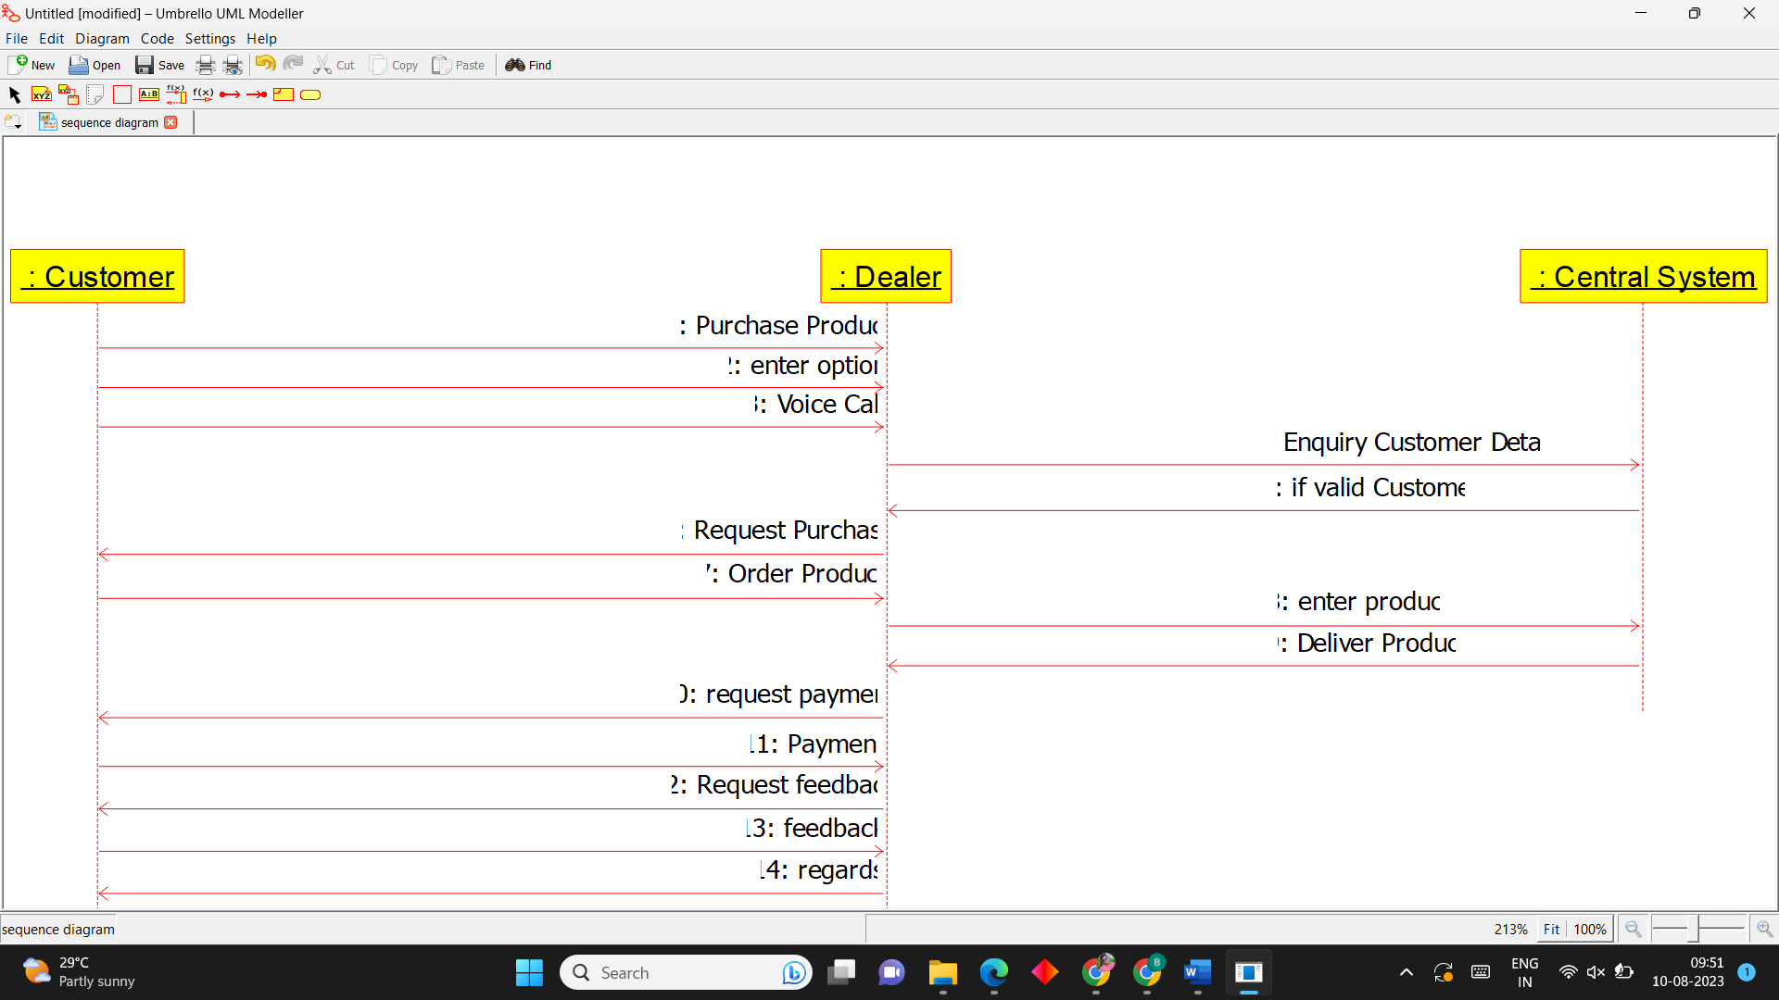

**4.E-Commerce Registration System**

**Use Case Diagram**

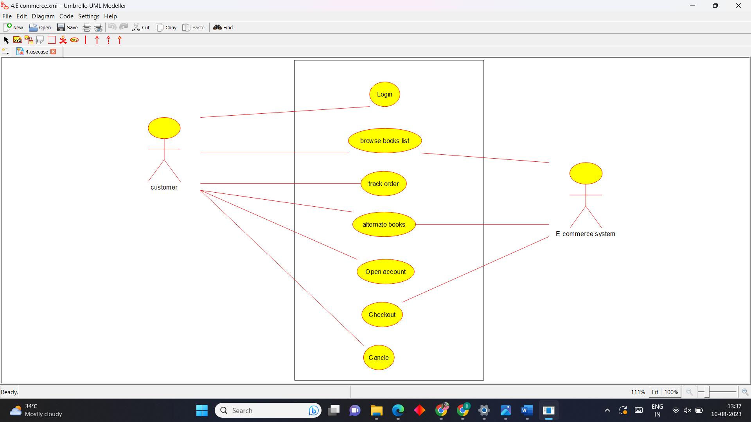

**Activity Diagram**

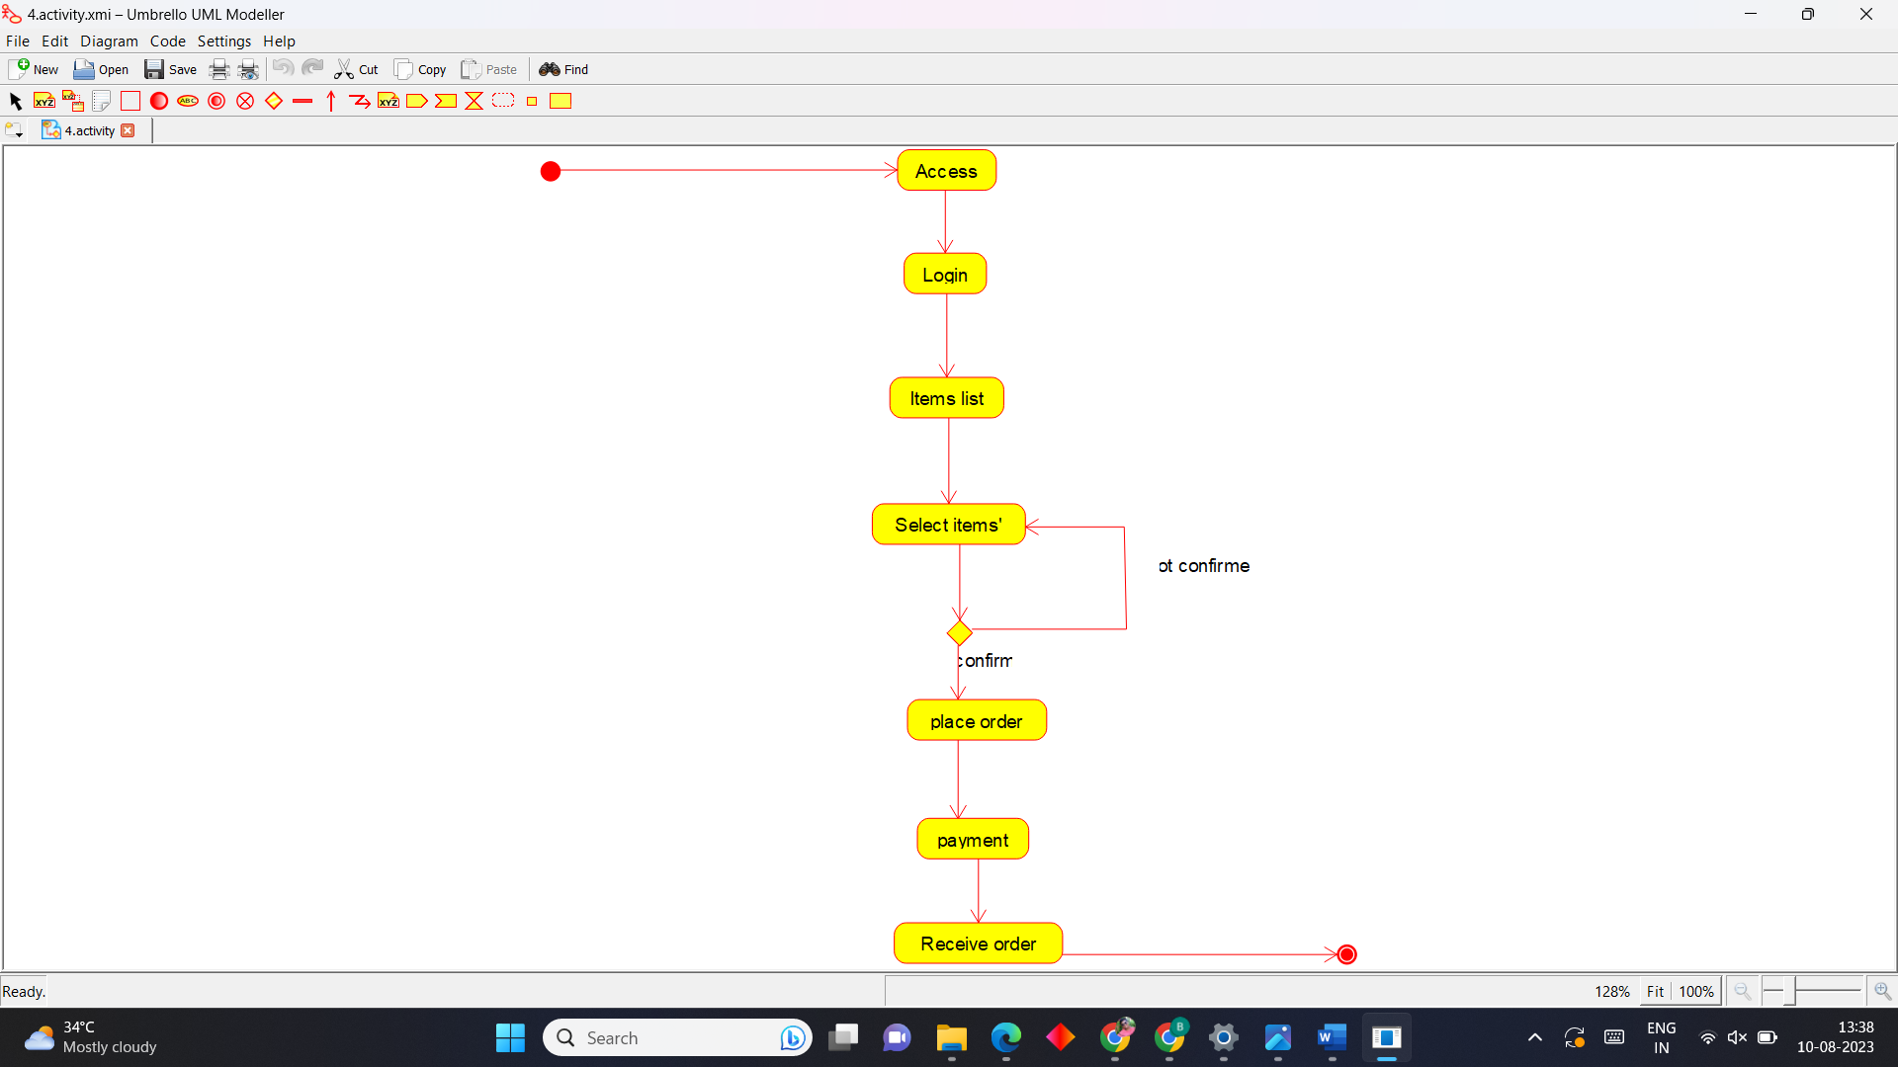

**Sequence Diagram**

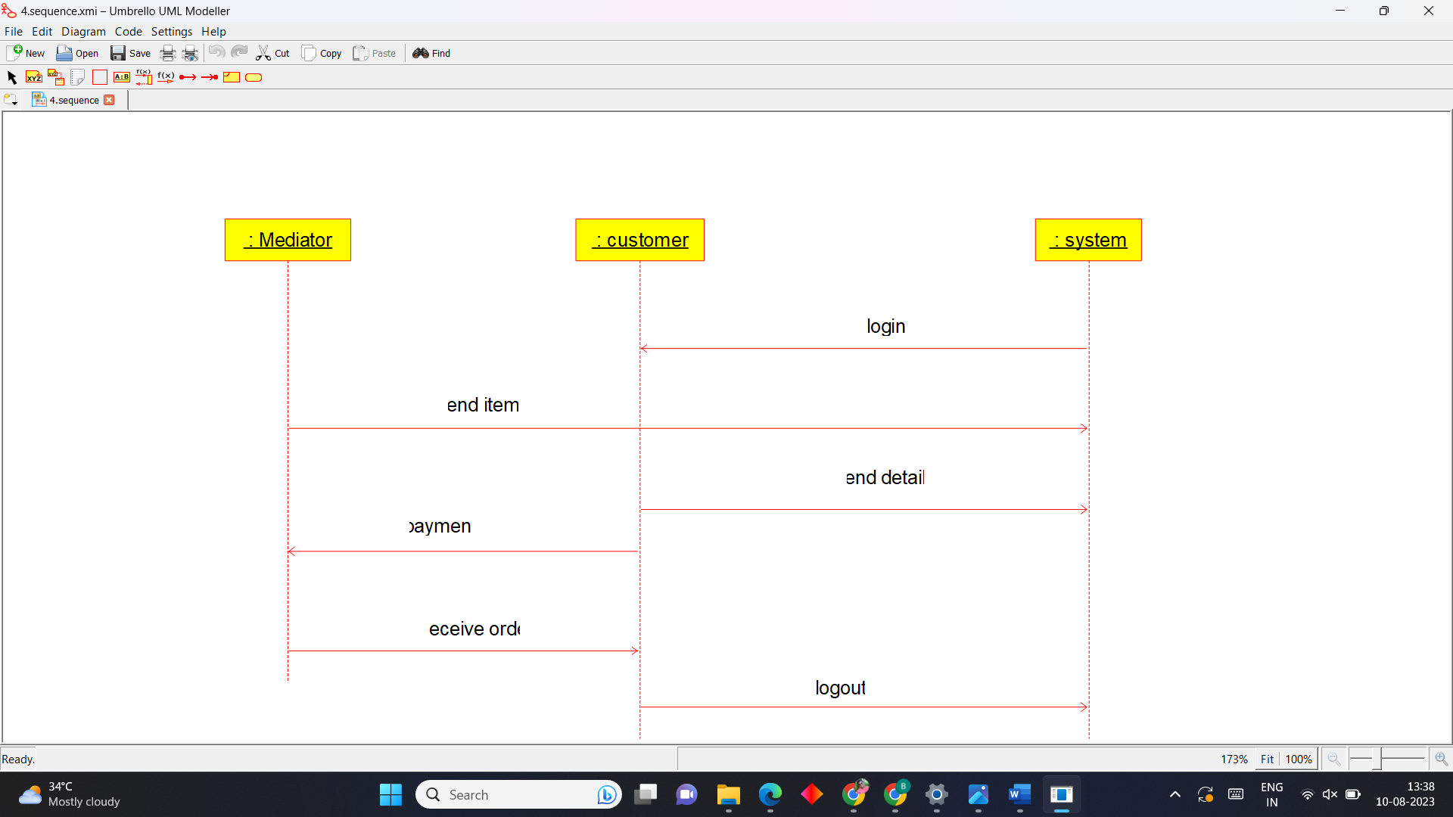

**5.Blood Bank Registration System**

**Use Case Diagram**

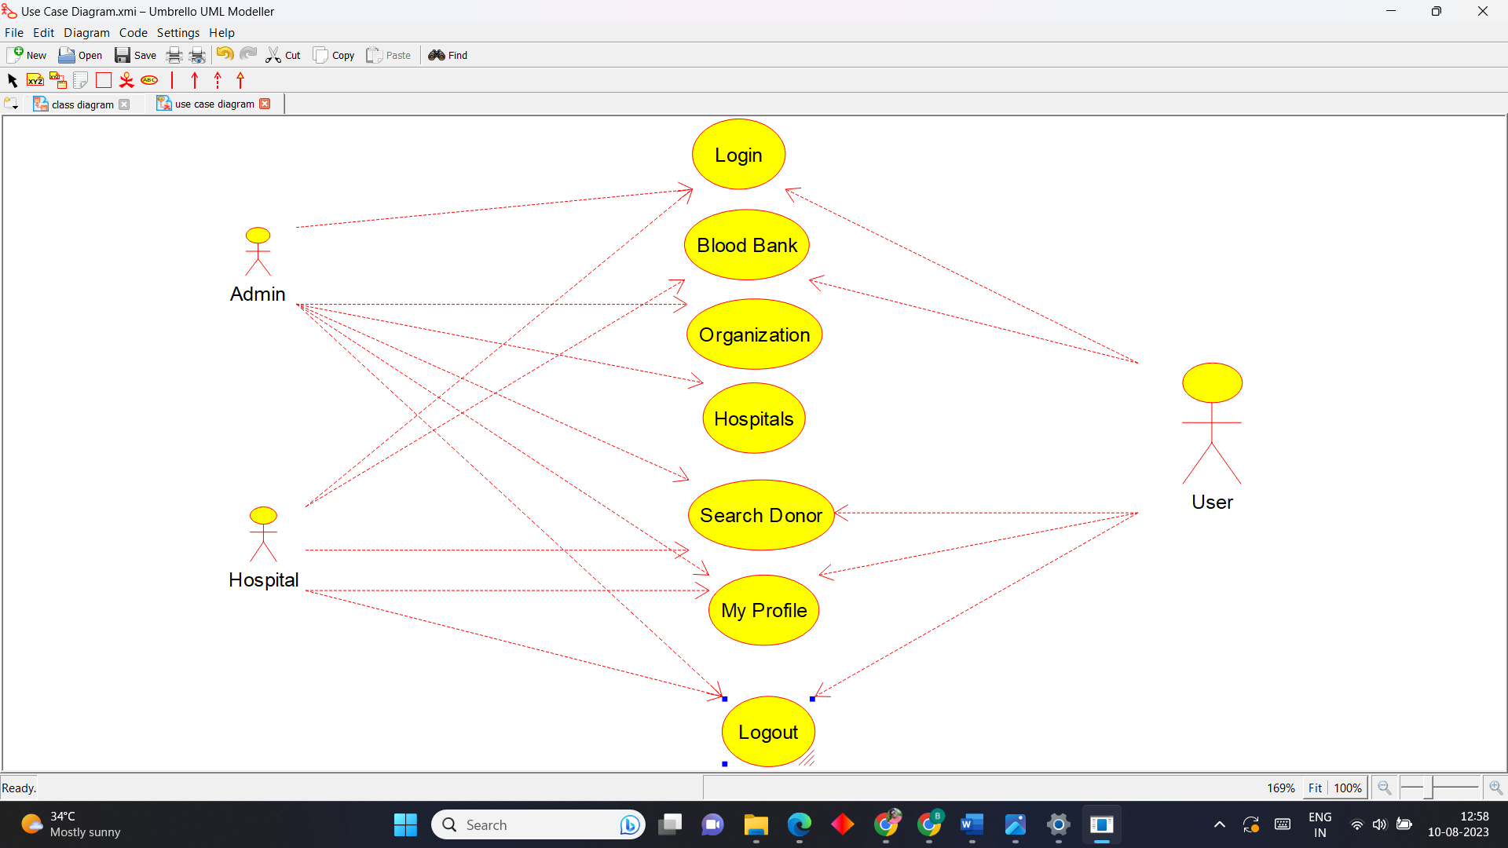

**Activity Diagram**

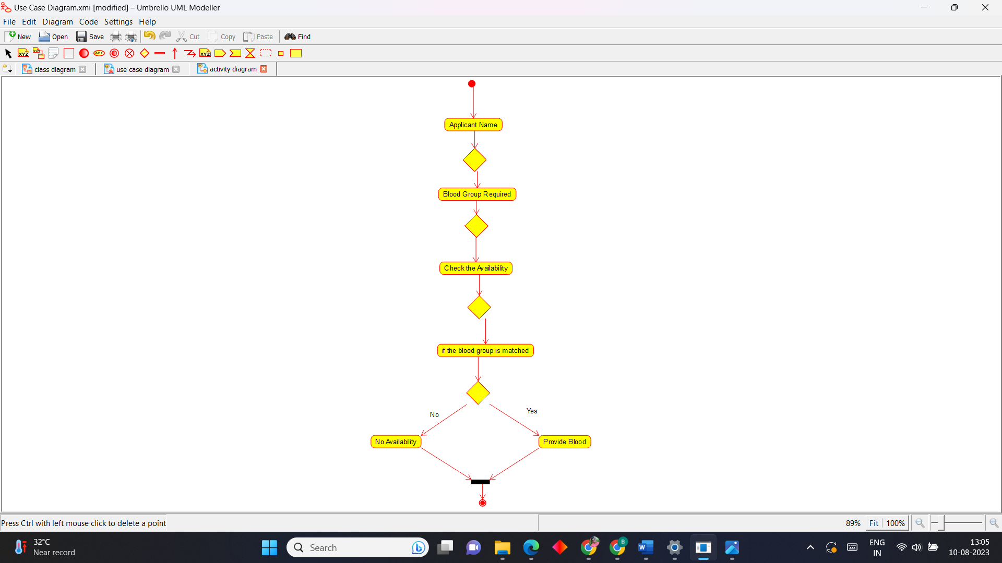

**Sequence Diagram**



**6.Online Internship Registration System**

**Use Case Diagram**

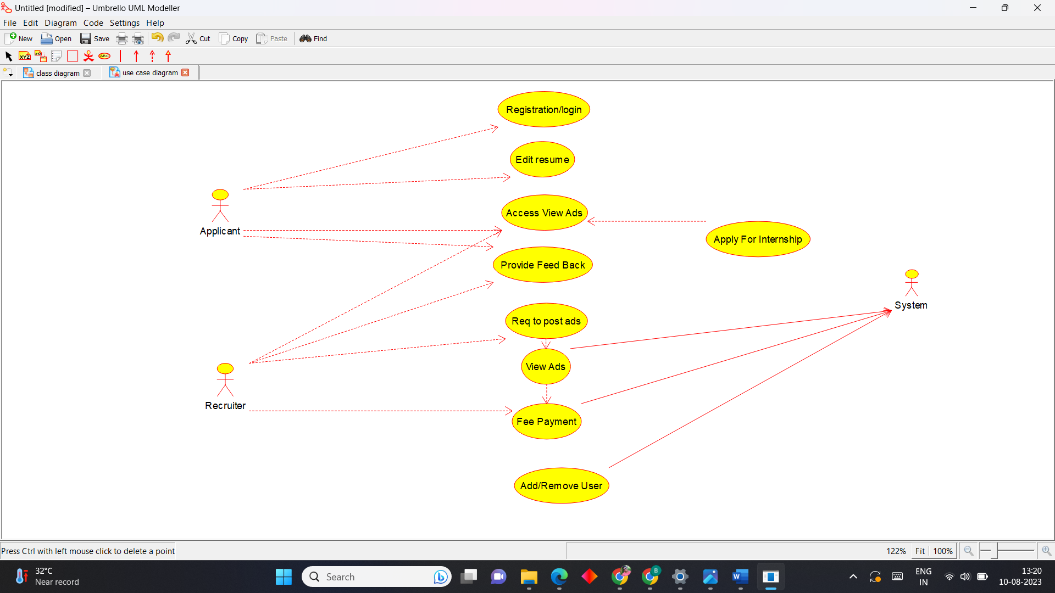

**Activity Diagram**

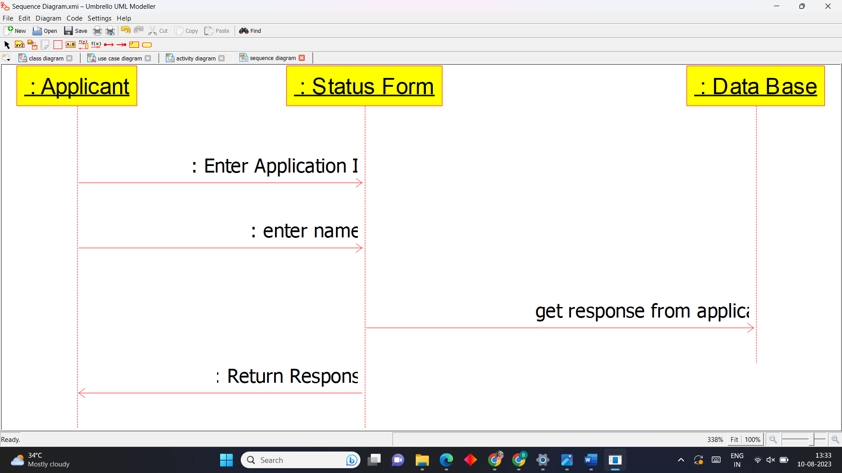

**7.Vehicle Registration Number Registering System**

**Use Case Diagram**

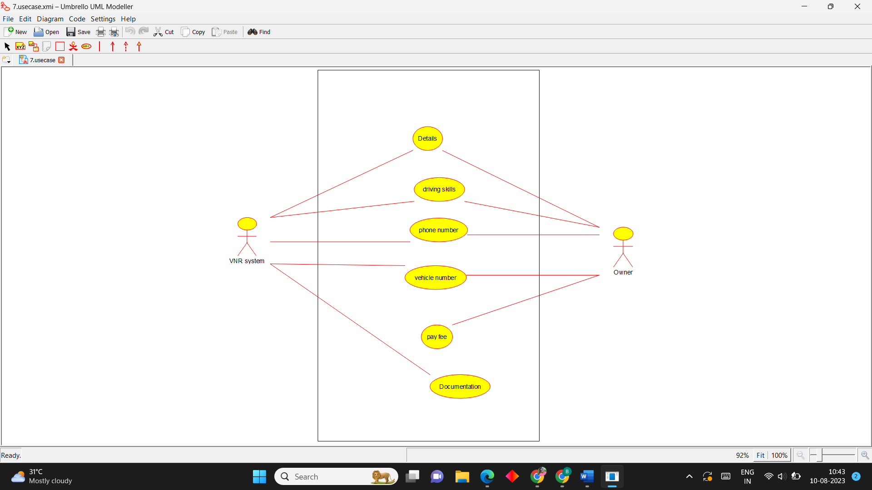

**Activity Diagram**

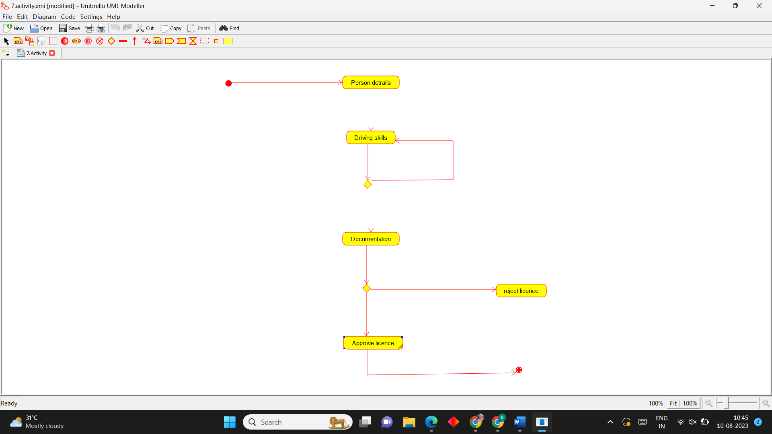

**Sequence Diagram**

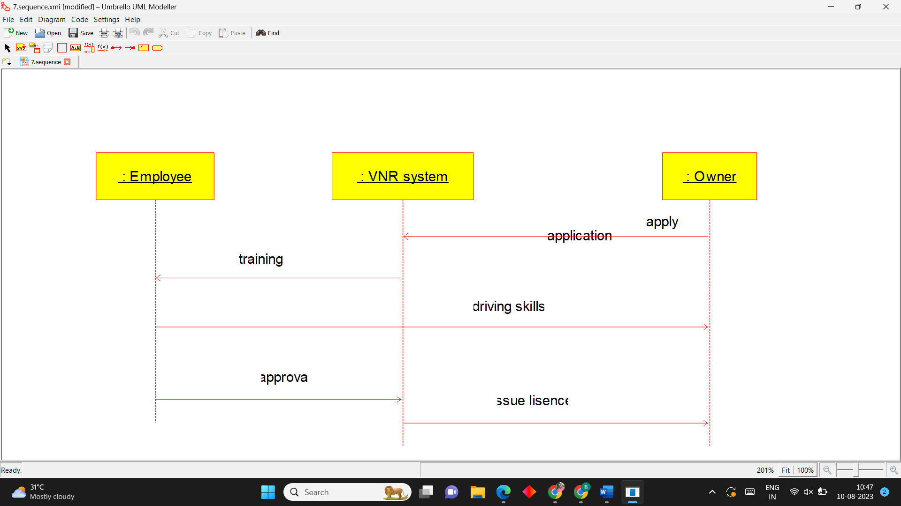

**8.Food Order System**

**Use Case Diagram**

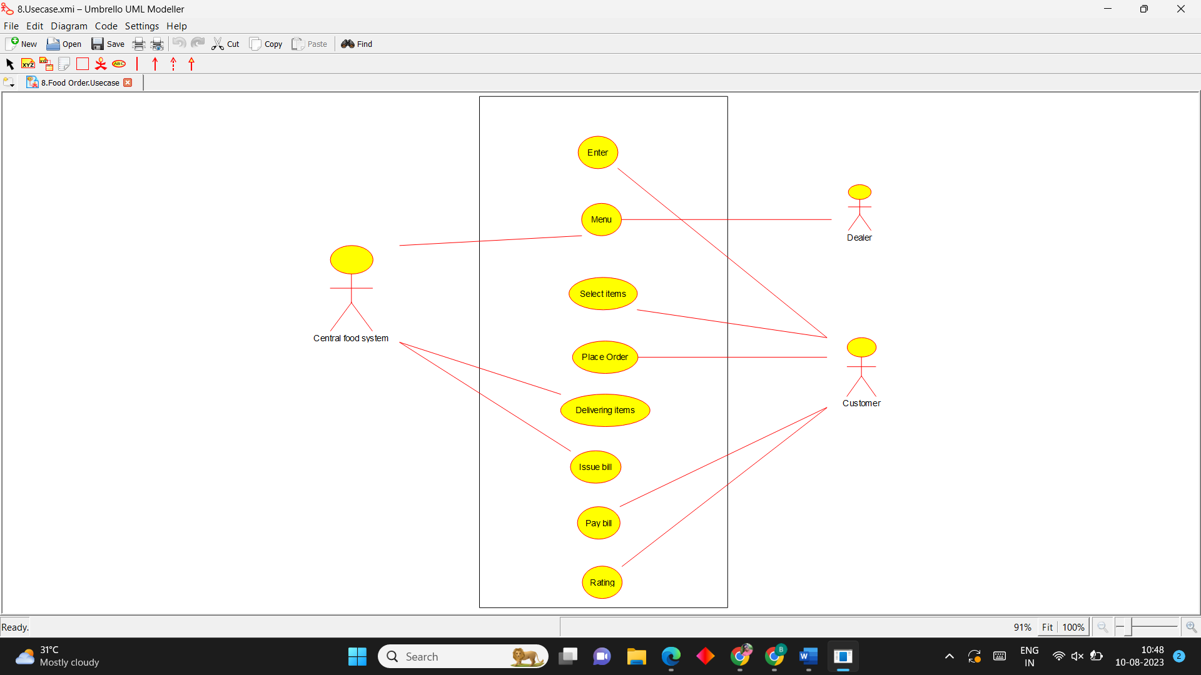

**Activity Diagram**

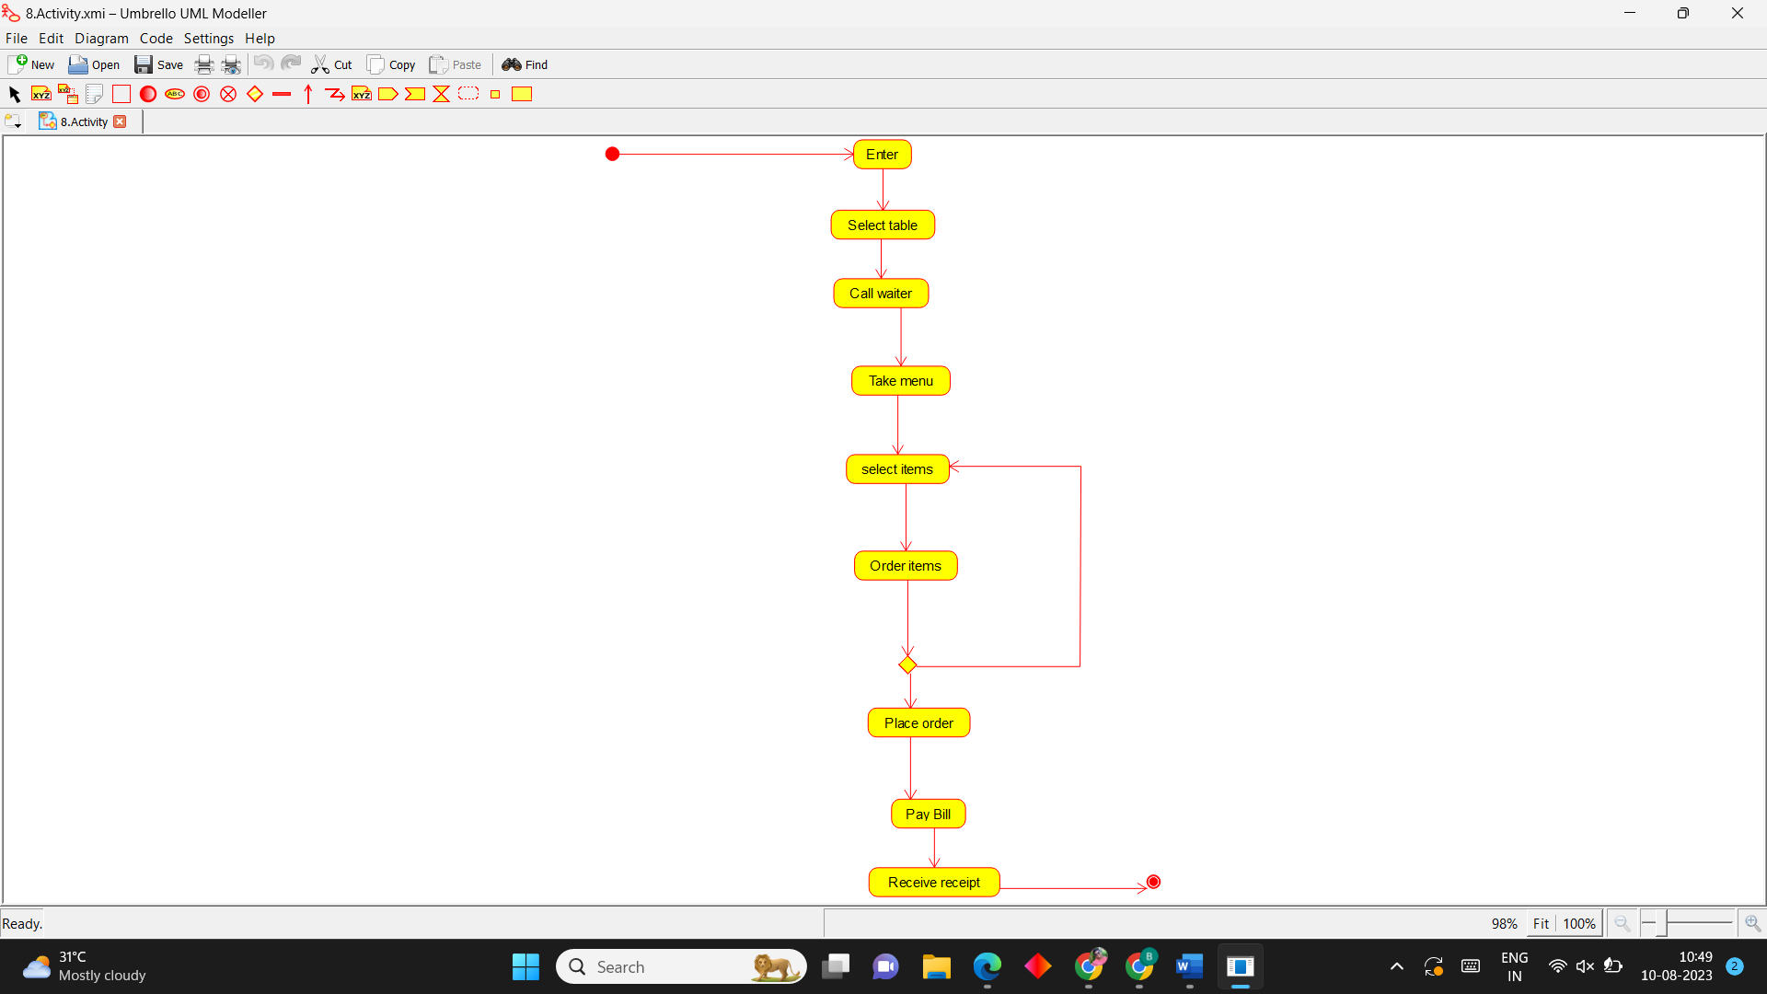

**Sequence Diagram**

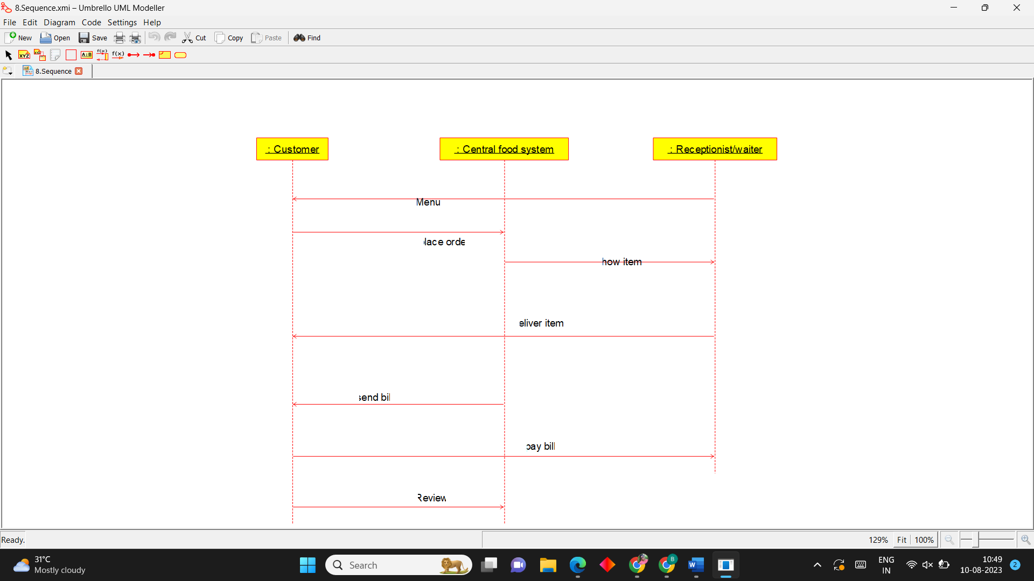

**9. Home Service System**

**Use Case Diagram**

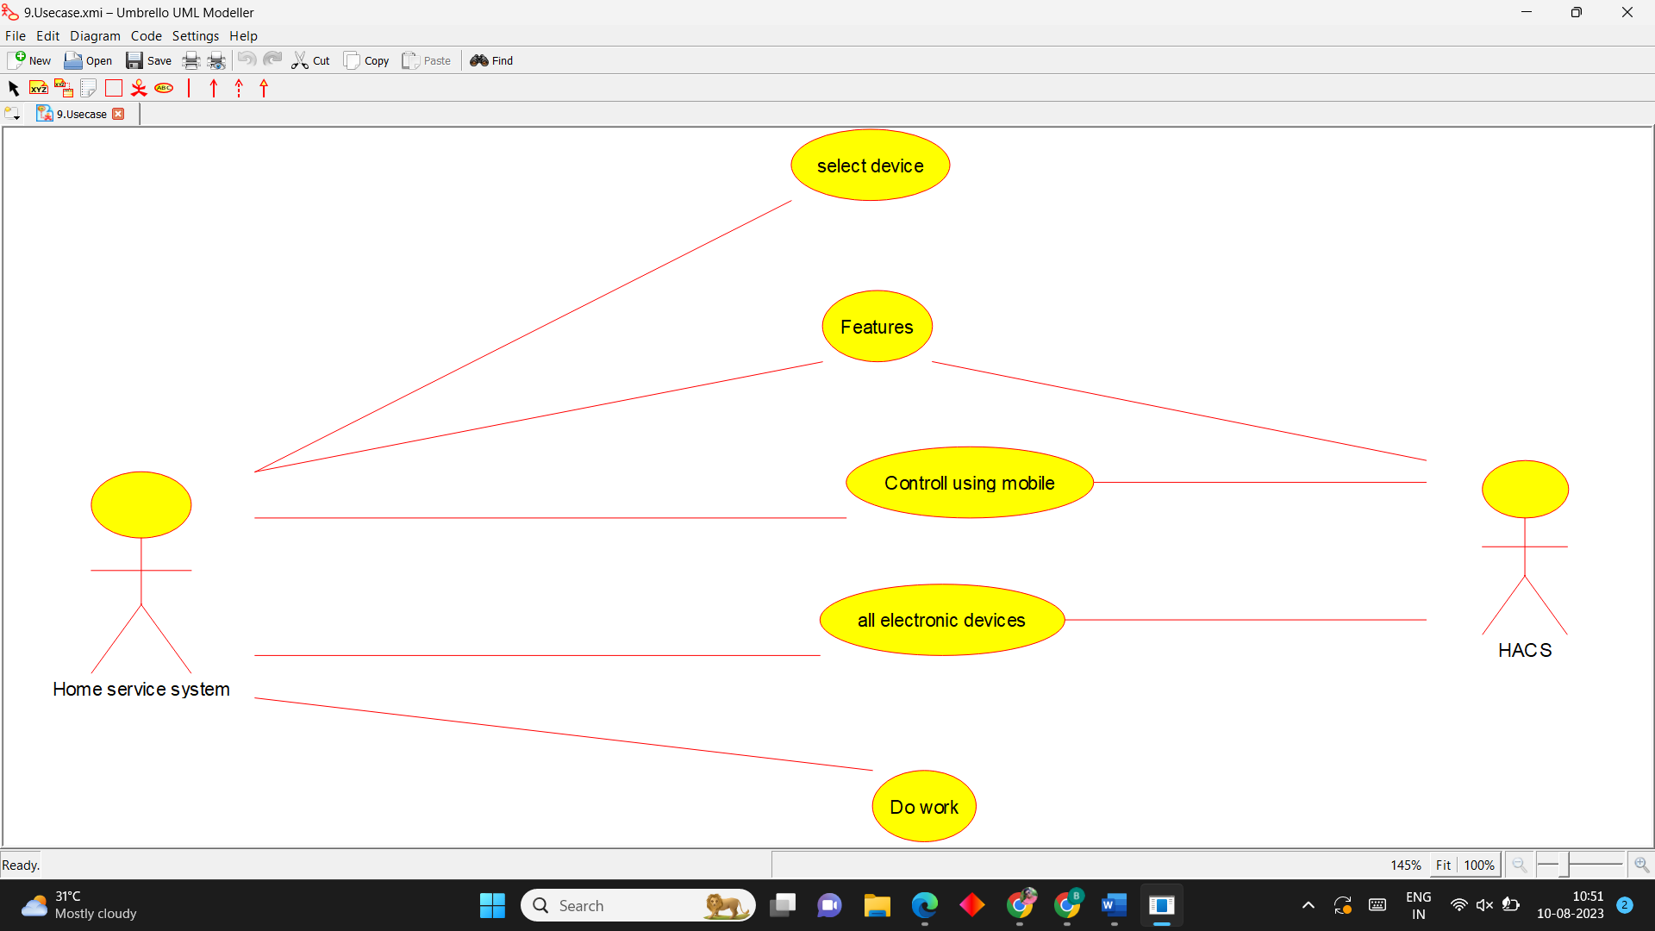

**Activity Diagram**

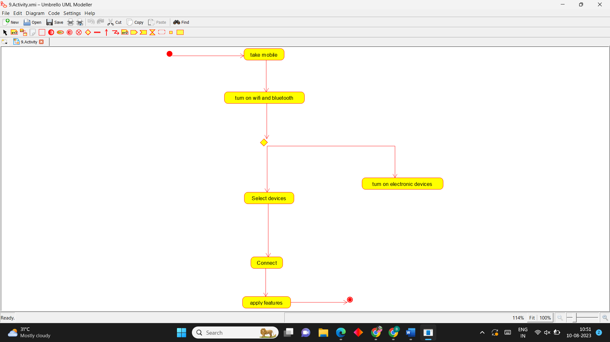

**Sequence Diagram**

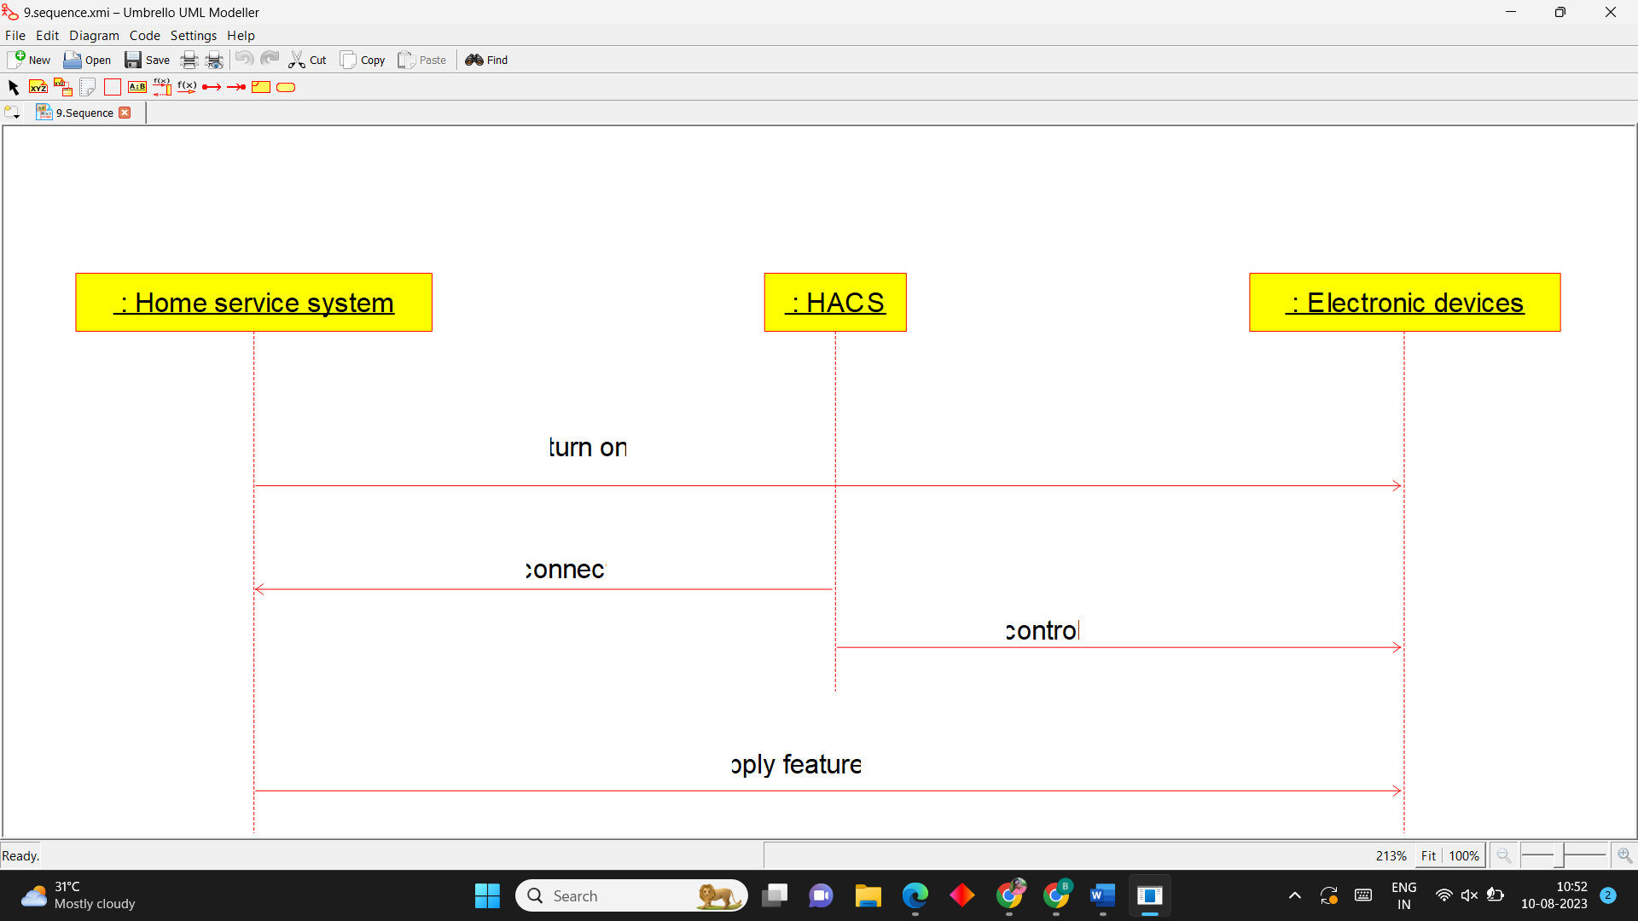

**10.Library Management System**

**Use Case Diagram**

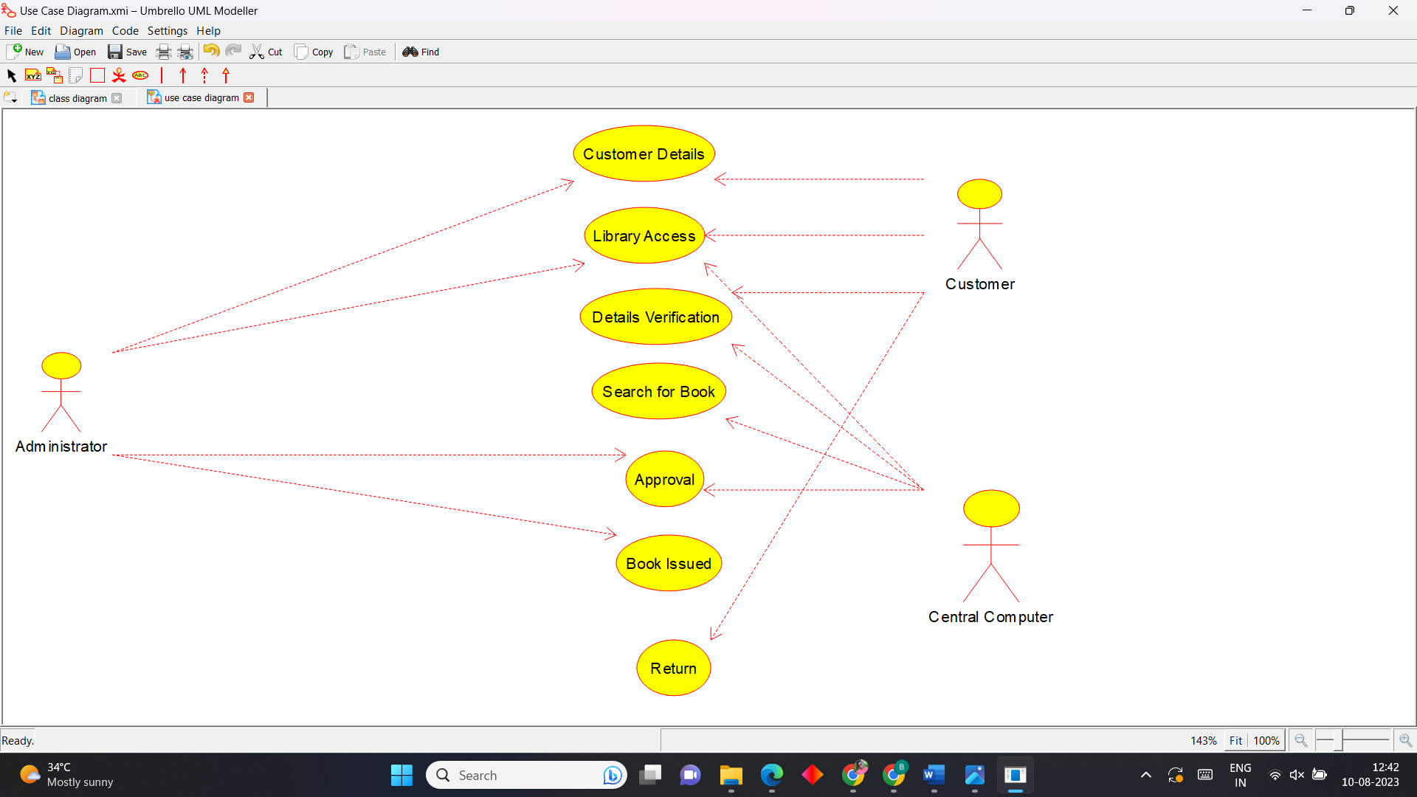

**Activity Diagram**

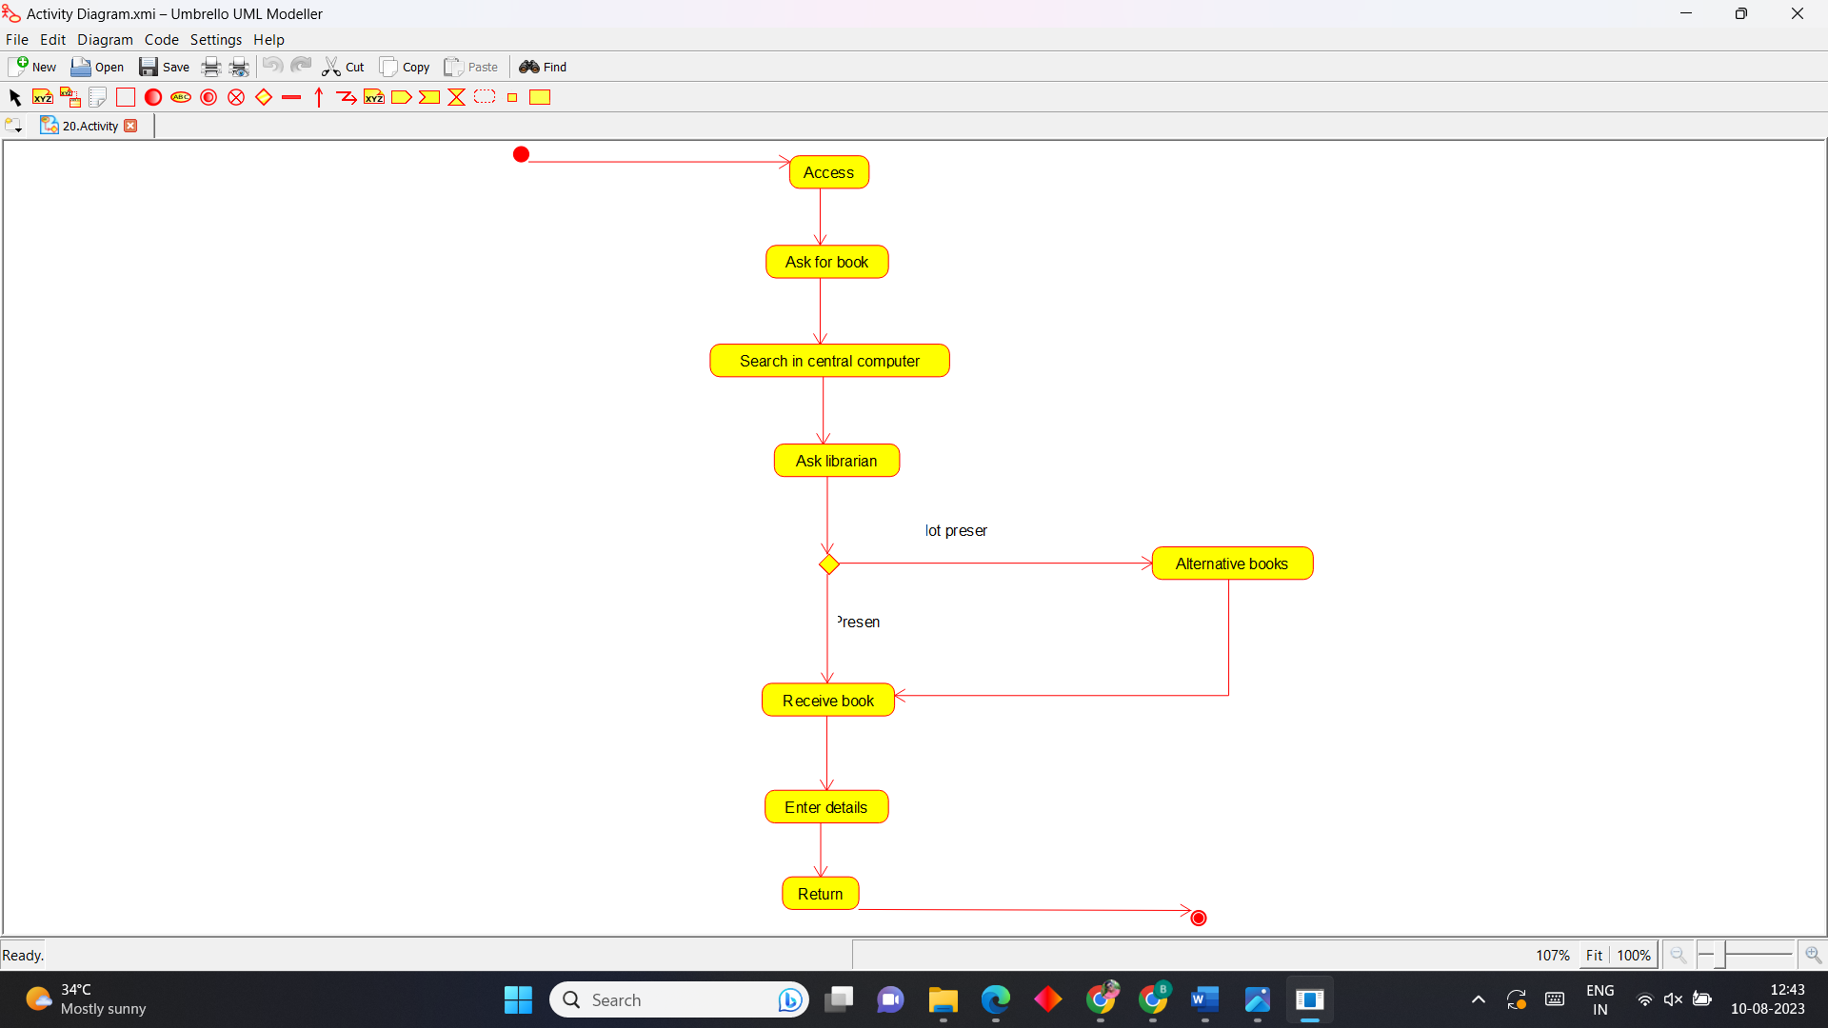

**Sequence Diagram**

